1. Suppose that you own a wind farm with five wind turbines of the same type, and suppose that you have kept the records of their first failure times ${t_{1}}^{obs}, …, {t_{5}}^{obs}$, which are 14, 6, 8, 11, and 9 months.
2. Draw the sample (empirical) reliability function.

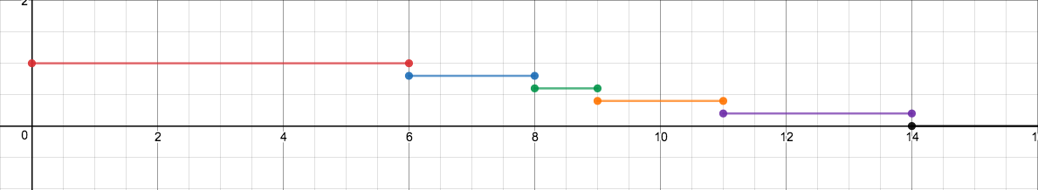

1. Calculate the area under the empirical reliability function.
$$A=6*1+2*\frac{4}{5}+1*\frac{3}{5}+2*\frac{2}{5}+3*\frac{1}{5}$$

$$A=9+\frac{3}{5}=9.6$$

2. Calculate the sample mean $\overline{t}$ of the data.
$$\overline{t}=\frac{\left(6+8+9+11+14\right)}{5}=9.6$$

3. Construct a $95\%$ (asymptotic) confidence interval for the population MTTF (mean time to failure) when someone has told you that, based on historical records, the population variance $σ^{2}$ is 9.

$$\overline{t}-1.96\frac{σ}{\sqrt{n}}≤μ≤\overline{t}+1.96\frac{σ}{\sqrt{n}}$$

$$9.6-1.96\frac{\sqrt{9}}{\sqrt{5}}≤μ≤9.6+1.96\frac{\sqrt{9}}{\sqrt{5}}$$

$$9.6-1.96\frac{3}{\sqrt{5}}≤μ≤9.6+1.96\frac{3}{\sqrt{5}}$$

Therefore, the 95% confidence interval is

$$\left[9.6-1.96\frac{3}{\sqrt{5}}, 9.6+1.96\frac{3}{\sqrt{5}}\right]$$

1. Calculate the sample standard deviation $\hat{σ}$ of the data.
$$\hat{σ}=\sqrt{\frac{1}{n}\sum_{i=1}^{n}{\left(t_{i}-\overline{t}\right)}}$$

$$\hat{σ}=\sqrt{\frac{1}{5}\left({\left(6-9.6\right)}^{2}+{\left(8-9.6\right)}^{2}+{\left(9-9.6\right)}^{2}+{\left(11-9.6\right)}^{2}+{\left(14-9.6\right)}^{2}\right)}$$

$$\hat{σ}=\sqrt{\frac{1}{5}\left({3.6}^{2}+{1.6}^{2}+{0.6}^{2}+{1.4}^{2}+{4.4}^{2}\right)}$$

$$\hat{σ}=\sqrt{\frac{1}{5}\left(12.96+2.56+0.36+1.96+19.36\right)}$$

$$\hat{σ}=\sqrt{\frac{37.2}{5}}$$

2. Construct a $95\%$ (asymptotic) confidence interval for the population MTTF when no information about the population variance $σ^{2}$ is available.

$$\overline{t}-1.96\frac{\hat{σ}}{\sqrt{n}}≤μ≤\overline{t}+1.96\frac{\hat{σ}}{\sqrt{n}}$$

$$9.6-1.96\frac{\sqrt{\frac{37.2}{5}}}{\sqrt{5}}≤μ≤9.6+1.96\frac{\sqrt{\frac{37.2}{5}}}{\sqrt{5}}$$

$$9.6-1.96\frac{\sqrt{37.2}}{\sqrt{5}}\frac{1}{\sqrt{5}}≤μ≤9.6+1.96\frac{\sqrt{37.2}}{\sqrt{5}}\frac{1}{\sqrt{5}}$$

$$9.6-1.96\frac{\sqrt{37.2}}{5}≤μ≤9.6+1.96\frac{\sqrt{37.2}}{5}$$

Therefore, the 95% interval is

$$\left[9.6-1.96\frac{\sqrt{37.2}}{5},9.6+1.96\frac{\sqrt{37.2}}{5}\right]$$